**Bandit level 0**

“The goal of this level is for you to log into the game using SSH. The host to which you need to connect is **bandit.labs.overthewire.org**, on port 2220. The username is **bandit0** and the password is **bandit0**. Once logged in, go to the [Level 1](https://overthewire.org/wargames/bandit/bandit1.html) page to find out how to beat Level 1.”

I opened my Kali Linux VM

Opened the terminal I tried just ssh in to the bandit.labs.overthewire.org and tried the password and got denied

I then Tried the next command: 

After that, I entered my password given above

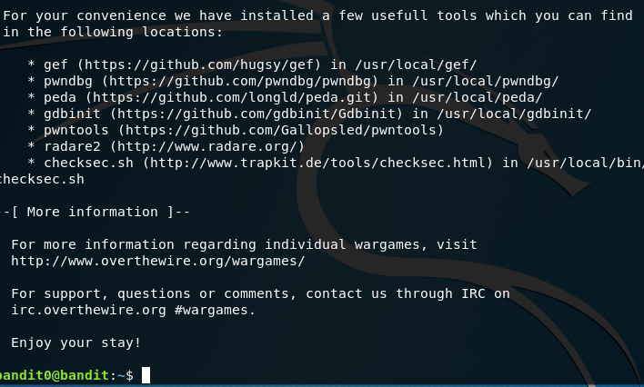

Success!